

COSHH ASSESSMENT SHEET

Date of Assessment: Assessment No: CA Assessor: Daniel Looney

Overall Assessment Rating of Risk [ √ ] Low [ ] Medium [√ ] High [ ]

|  |  |  |  |  |  |  |  |  |  |  |  |  |  |  |  |  |  |  |  |  |
| --- | --- | --- | --- | --- | --- | --- | --- | --- | --- | --- | --- | --- | --- | --- | --- | --- | --- | --- | --- | --- |
| **Work Activity:** | | | | | | | | | | | **Degreaser** | | | | | | | | | |
| **Persons at Risk:** | | | | User [√ ] Colleagues [√ ] Contractors [ ] Public [ ] Others **[** ] | | | | | | | | | | | | | | | | |
|  | | | | | | | | | | | | | | | | | | | | |
| **Name of Hazardous Substance:** | | | | | **Power Plus HD** | | | | | | | | | | | | | | | |
| **Manufacturer (address/tele no):** | | | | | Chela  68 Bilton Way,  Enfield  EN3 7NH  Tel: 020 8805 2150  sales@chela.co.uk | | | | | | | | | | | | | | | |
| **SDS Version:** | | | | | 02 | | | | | | | | | | | | | | | |
| **Supplier (address/tele no):** | | | | | Chela Ltd | | | | | | | | | | | | | | | |
| **Hazard data sheet attached:** | | | | | Yes [√] No [ ] | | | | | | | | | | | | | | | |
| **Description/colour:** | | | | | Orange | | | | | | | | | | | | | | | |
|  | **Container size in litres/kg** | | |  | **20**  **litre/kg** | | | **10**  **litre/kg** | | | | **5 litre/kg** | | | **200>litre/**  **208kg** | | **< litre/kg** | | **Other** | |
|  | (tick as appropriate) | |  |  |  | | |  | | | |  | | | √ | |  | |  | |
| **HAZARD** (tick all that apply) | | | | | | | | | | | | | | | | | | | | |
|  | Corrosive | Flammable | Oxidising | | | | Corrosive | | Toxic | | | | Environmentally damaging | |  | | Health hazard | | Compressed gas |  |
|  | Explosive (Symbol: exploding bomb) | Flammable (Symbol: flame) | Oxidising (Symbol: flame over circle) | | | | Corrosive (Symbol: Corrosion) | | Acute toxicity (Symbol: Skull and crossbones) | | | | Hazardous to the environment (Symbol: Dead tree and fish) | | Health hazard/Hazard ous to the ozone layer (Symbol: Exclamation mark) | | Serious health hazard (Symbol: health hazard) | | Gas under pressure (Symbol: Gas cylinder) |  |
|  |  |  |  | | | | √ | |  | | | |  | |  | |  | |  |  |
| **Known exposure levels:**  **W.E.L.** (where applicable) | | | | | |  | | | | | | | | | | | | | | |
| **Likely route of entry to body:**  (tick all that apply) | | | | | | **Inhaled** | | | | **Ingested** | | | | **Absorbed by skin** | | **Eyes** | | **Other** | | |
|  | | | | | | √ | | | | √ | | | | √ | | √ | |  | | |
| **Areas of use/exposure:** | | | | | | **Floor cleaner/degreaser** | | | | | | | | | | | | | | |

|  |  |  |  |
| --- | --- | --- | --- |
| **CONTROL MEASURES** | | | |
| **Can the exposure/use be eliminated or substituted?** | (tick as appropriate) | **Yes** | **No √** |

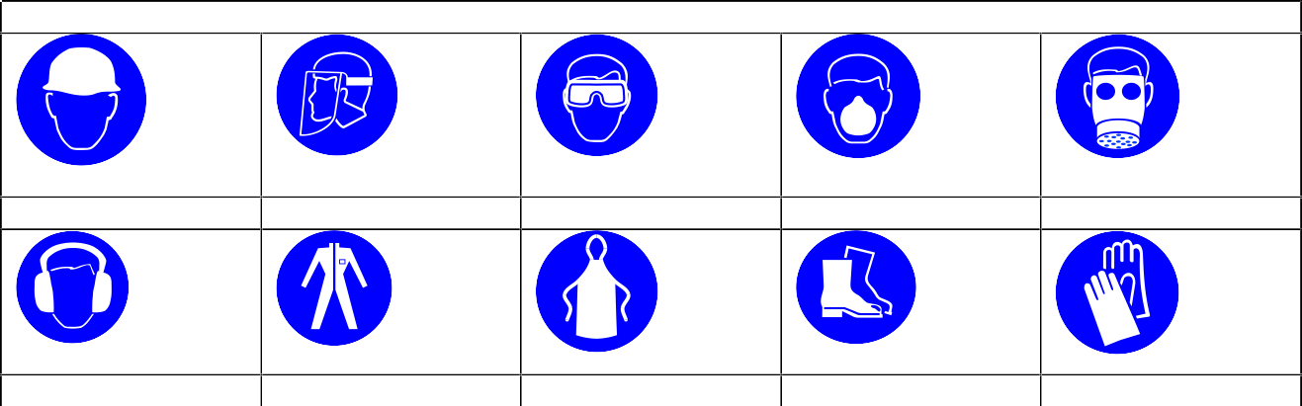

**PERSONAL PROTECTIVE EQUIPMENT REQUIREMENT.** (tick as appropriate)

**Hard Hats**

**Face Protection**

**Eye Protection**

**Dust Mask**

**Respirator**

**Ear Protection**

**Overalls**

**Apron**

**Foot Protection**

**Gloves**

|  |  |  |  |  |  |  |  |
| --- | --- | --- | --- | --- | --- | --- | --- |
| **Is monitoring required?** | (tick as appropriate) | | | **Yes √** | | **No** | |
| **Local exhaust ventilation required?** | (tick as appropriate) | | | **Yes** | | **No √** | |
| **Documented working method available on safe use and handling?** | (tick as appropriate) | | | **Yes** √ | | **No** | |
| **Storage:** | **Maximum amount to be stored on site** | **Secure store out of reach of service users and children** | **Store to be well ventilated** | | **Separate storage facility available or required** | | **Other** |
| (tick all that apply) | √ | √ | √ | |  | |  |
| **Method of use.** | **Use undiluted** | **Use diluted** | **Wash hands after use** | | **Do not mix with other products** | | **Special precautions** |
| (tick all that apply) |  | √ | √ | | √ | |  |
| **State any special/storage requirements or other precautions not listed above:**  Suitable fire extinguishing media: Water spray. Dry powder. Foam. Carbon dioxide | | | | | | | |

|  |  |  |  |
| --- | --- | --- | --- |
| **Type of PPE & Model Nos** | | | **Type of PPE & Model Nos** |
| Chemical resistant gloves: EN 374 | | | Safety glasses EN 166 |
| **Who orders PPE?** | **Area manager or Site manager** | | |
| **EMERGENCY CONTROLS** | | | |
| **First Aid: Eyes** | | Bathe the eye with running water for 15 minutes. Transfer to hospital for specialist examination. | |
| **Skin** | | Remove all contaminated clothes and footwear immediately unless stuck to skin.  Drench the affected skin with running water for 10 minutes or longer if substance is still on skin.  Transfer to hospital if there are burns or symptoms of poisoning. | |
| **Inhalation** | | Remove casualty from exposure ensuring one's own safety whilst doing so. May cause irritation to mucous membranes. If unconscious and breathing is OK, place in the recovery position. If conscious, ensure the casualty sits or lies down. Transfer to hospital as soon as possible. | |
| **Ingestion** | | **Ingestion:** Wash out mouth with water. Do not induce vomiting. Give 1 cup of water to drink every 10 minutes.  If unconscious, check for breathing and apply artificial respiration if necessary.  If unconscious and breathing is OK, place in the recovery position. Transfer to hospital as soon as possible. | |
| **Dealing with spillage:** | | Clean-up should be dealt with only by qualified personnel familiar with the specific substance. Absorb into dry earth or sand. Transfer to a closable, labelled salvage container for disposal by an appropriate method. | |
| **Disposal:** | | Chela will collect empty containers | |
| **Precautions already in place:** | | PPE, method statements, induction & on-going training | |
| **Advice available from?** | | Chela | |

2