

COSHH ASSESSMENT SHEET

Date of Assessment: 24.09.24 Assessment No: CA 15 Assessor: Daniel Looney

Overall Assessment Rating of Risk [ √ ] Low [√ ] Medium [ ] High [ ]

|  |  |  |  |  |  |  |  |  |  |  |  |  |  |  |  |  |  |  |  |  |
| --- | --- | --- | --- | --- | --- | --- | --- | --- | --- | --- | --- | --- | --- | --- | --- | --- | --- | --- | --- | --- |
| **Work Activity:** | | | | | | | | | | | Multipurpose cleaning. | | | | | | | | | |
| **Persons at Risk:** | | | | User [√] Colleagues [√] Contractors [ ] Public [ ] Others **[** ] | | | | | | | | | | | | | | | | |
|  | | | | | | | | | | | | | | | | | | | | |
| **Name of Hazardous Substance:** | | | | | **Super Professional Green Washing up liquid** | | | | | | | | | | | | | | | |
| **Manufacturer (address/tele no):** | | | | | Mirius™  A Coventry Group Company  Woodhams Road, Siskin Drive, Coventry  CV3 4FX | | | | | | | | | | | | | | | |
| **SDS Version:** | | | | | 3.0 | | | | | | | | | | | | | | | |
| **Supplier (address/tele no):** | | | | | 02476 639 739 | | | | | | | | | | | | | | | |
| **Hazard data sheet attached:** | | | | | Yes [ √ ] No [ ] | | | | | | | | | | | | | | | |
| **Description/colour:** | | | | | Green | | | | | | | | | | | | | | | |
|  | **Container size in litres/kg** | | |  | **20**  **litre/kg** | | | **10**  **litre/kg** | | | | **5 litre/kg** | | | **>litre/kg** | | **< litre/kg** | | **Other** | |
|  | (tick as appropriate) | |  |  |  | | |  | | | | √ | | |  | |  | |  | |
| **HAZARD** (tick all that apply) | | | | | | | | | | | | | | | | | | | | |
|  | Corrosive | Flammable | Oxidising | | | | Corrosive | | Toxic | | | | Environmentally damaging | |  | | Health hazard | | Compressed gas |  |
|  | Explosive (Symbol: exploding bomb) | Flammable (Symbol: flame) | Oxidising (Symbol: flame over circle) | | | | Corrosive (Symbol: Corrosion) | | Acute toxicity (Symbol: Skull and crossbones) | | | | Hazardous to the environment (Symbol: Dead tree and fish) | | Health hazard/Hazard ous to the ozone layer (Symbol: Exclamation mark) | | Serious health hazard (Symbol: health hazard) | | Gas under pressure (Symbol: Gas cylinder) |  |
|  |  |  |  | | | |  | |  | | | |  | | √ | |  | |  |  |
| **Known exposure levels:**  **W.E.L.** (where applicable) | | | | | | NA | | | | | | | | | | | | | | |
| **Likely route of entry to body:**  (tick all that apply) | | | | | | **Inhaled** | | | | **Ingested** | | | | **Absorbed by skin** | | **Eyes** | | **Other** | | |
|  | | | | | |  | | | |  | | | | √ | | √ | |  | | |
| **Areas of use/exposure:** | | | | | | **Mild general-purpose cleaner** | | | | | | | | | | | | | | |

|  |  |  |  |
| --- | --- | --- | --- |
| **CONTROL MEASURES** | | | |
| **Can the exposure/use be eliminated or substituted?** | (tick as appropriate) | **Yes** | **No** √ |

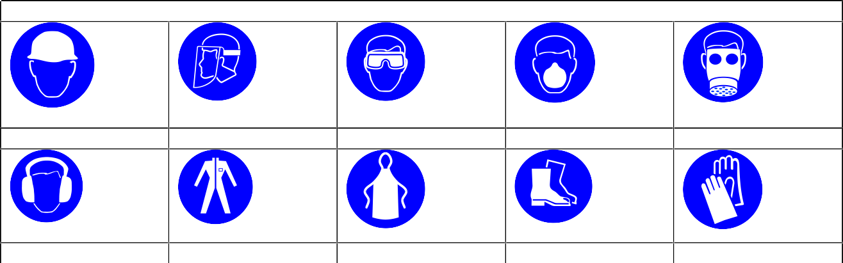

**PERSONAL PROTECTIVE EQUIPMENT REQUIREMENT.** (tick as appropriate)

**Hard Hats**

**Face Protection**

**Eye Protection:** √

**Dust Mask**

**Respirator**

**Ear Protection**

**Overalls**

**Apron**

**Foot Protection**

**Gloves:** √

|  |  |  |  |  |  |  |  |
| --- | --- | --- | --- | --- | --- | --- | --- |
| **Is monitoring required?** | (tick as appropriate) | | | **Yes** | | **No** √ | |
| **Local exhaust ventilation required?** | (tick as appropriate) | | | **Yes** | | **No** √ | |
| **Documented working method available on safe use and**  **handling?** | (tick as appropriate) | | | **Yes** √ | | **No** | |
| **Storage:** | **Maximum amount to be stored on site** | **Secure store out of reach of service**  **users and children** | **Store to be well ventilated** | | **Separate storage facility available or required** | | **Other** |
| (tick all that apply) |  | √ | √ | |  | |  |
| **Method of use.** | **Use undiluted** | **Use diluted** | **Wash hands after use** | | **Do not mix with other products** | | **Special precaution s** |
| (tick all that apply) |  | √ | √ | | √ | |  |
| **State any special/storage requirements or other precautions not listed above:**  Suitable extinguishing media: Not flammable. Use media suitable for surrounding fire | | | | | | | |

|  |  |  |  |
| --- | --- | --- | --- |
| **Type of PPE & Model Nos** | | | **Type of PPE & Model Nos** |
| Safety Glasses EN166 | | | Gloves – EN374 Chemical resistant |
| **Who orders PPE?** | **Area Manager** | | |
| **EMERGENCY CONTROLS** | | | |
| **First Aid: Eyes** | | Rinse immediately with plenty of water. Remove any contact lenses and open eyelids wide apart. Continue to rinse for at least 15 minutes. Get medical attention if symptoms are severe or persist after washing. Show this Safety Data Sheet to the medical personnel. | |
| **Skin** | | Wash skin with plenty of water. | |
| **Inhalation** | | Move affected person to fresh air at once. Rinse nose and mouth with water. Get medical attention if any discomfort continues g | |
| **Ingestion** | | Never give anything by mouth to an unconscious person. Do not induce vomiting. Rinse mouth thoroughly with water. Get medical attention if any discomfort continues. | |
| **Dealing with spillage:** | | Take up liquid spill into absorbent material. | |
| **Disposal:** | | Empty containers to be disposed of as hazardous waste | |
| **Precautions already in place:** | | PPE, method statements, induction & on-going training | |
| **Advice available from?** | | Mirius | |

2